**1.Reversing a 32-bit signed intergers:**

**code:**

#include <stdio.h>

int reversDigits(int num)

{

int rev_num = 0;

while (num != 0) {

rev_num = rev_num * 10 + num % 10;

num = num / 10;

}

return rev_num;

}

int main()

{

int num = 5896;

printf("Reverse of number is %d", reversDigits(num));

return 0;

}

**Output:** Reverse of number is 6985

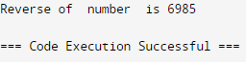

**2.Vaild string no not:**

**code:**

#include <stdio.h>

#include <stdbool.h>

#define MAX_SIZE 100

int main() {

char stack[MAX_SIZE];

int top = -1;

char mapping[MAX_SIZE];

mapping[')'] = '(';

mapping[']'] = '[';

mapping['}'] = '{'; char *strings[] = {"((()))", "([{()}])", "(()", "([)]"};

for (int k = 0; k < sizeof(strings) / sizeof(strings[0]); k++) {

char *s = strings[k];

top = -1;

bool valid = true;

for (int i = 0; s[i] != '\0'; i++) {

if (s[i] == '(' || s[i] == '[' || s[i] == '{') {

stack[++top] = s[i];

} else if (s[i] == ')' || s[i] == ']' || s[i] == '}') {

if (top == -1 || stack[top] != mapping[s[i]]) {

valid = false;

break;

} else {

top--;

}

}

}

if (top != -1) valid = false;

printf("%s is %s\n", s, valid ? "valid" : "not valid");

}

return 0;

}

**Output:** ((( ))) is valid

([{( )}]) is valid

(( ) is not valid

([ )] is not valid

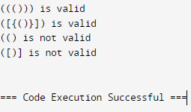

**3.Merging two arrays:**

**code:**

#include <stdio.h>int main(){

int arr1size = 5, arr2size = 5, arr_resultsize, i, j;

int a[5] = { 1, 2, 3, 4, 5 };

int b[5] = { 6, 7, 8, 9, 10 };

arr_resultsize = arr1size + arr2size;

int c[arr_resultsize];

for (i = 0; i < arr1size; i++) {

c[i] = a[i];

}

for (i = 0, j = arr1size;j < arr_resultsize && i < arr2size; i++, j++) {

c[j] = b[i];

}

printf("Merging of arrays is ");

for (i = 0; i < arr_resultsize; i++) {

printf("%d ", c[i]);

}

return 0;

}

**Output:** 1 2 3 4 5 6 7 8 9 10

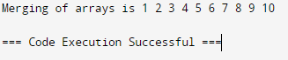

**4.Array Finding Duplication Values:**

**code:**

#include <stdio.h>

int main()

{

int arr[] = {1, 2, 3, 4, 2, 7, 8, 8, 3};

int length = sizeof(arr)/sizeof(arr[0]);

printf("Duplicate elements in given array: ");

for(int i = 0; i < length; i++) {

for(int j = i + 1; j < length; j++) {

if(arr[i] == arr[j])

printf("%d ", arr[j]);

}

}

return 0;

} **output:** Duplicate elements in given array : 2,3,8

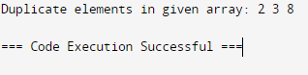

**5.Merging of :**

**code:**

#include <stdio.h>

#define MAX_SIZE 100

void merge_arrays(int arr1[], int size1, int arr2[], int size2, int merged[]) {

int i, j, k;

for (i = 0; i < size1; i++) {

merged[i] = arr1[i];

}

for (j = 0, k = size1; j < size2; j++, k++) {

merged[k] = arr2[j];

}

}

int main() {

int arr1[] = {1, 2, 3};

int size1 = sizeof(arr1) / sizeof(arr1[0]);

int arr2[] = {4, 5, 6};

int size2 = sizeof(arr2) / sizeof(arr2[0]);

int merged[MAX_SIZE];

merge_arrays(arr1, size1, arr2, size2, merged);

printf("Merged list: ");

for (int i = 0; i < size1 + size2; i++) {

printf("%d ", merged[i]);

}

printf("\n");

return 0;

}

**output:** Merged list: 1 2 3 4 5 6

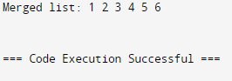

**6.Registration Number Search:code:**

#include <stdio.h>

#include <stdbool.h>

#define MAX_SIZE 100

bool search_registration_number(int reg_numbers[], int size, int target) {

for (int i = 0; i < size; i++) {

if (reg_numbers[i] == target) {

return true;

}

}

return false;

}

int main() {

int reg_numbers[MAX_SIZE] = {123, 456, 789, 1011, 1213, 1234};

int size = 6;

int target = 1234;

if (search_registration_number(reg_numbers, size, target)) {

printf("Registration number %d found!\n", target);

} else {

printf("Registration number %d not found.\n", target);

}

return 0;

}

**output:** Registration number 1234 found!

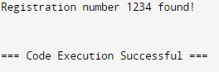

**7.Identify location of Element:**

**code:**

#include <stdio.h>

#define MAX_SIZE 100

int find_element(int arr[], int size, int target) {

for (int i = 0; i < size; i++) {

if (arr[i] == target) {

return i;

}

}

return -1;

}int main() {

int arr[MAX_SIZE] = {10, 20, 30, 40, 50};

int size = 5;

int target = 40;

int element = find_element(arr, size, target);

if (element!= -1) {

printf("Element %d found at element %d.\n", target,element);

} else {

printf("Element %d not found in the array.\n", target);

}

return 0;

}

**ouput:** Element 40 found at element 3.

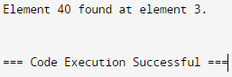

**8.Array Odd and even Values:**

**code:**

#include <stdio.h>

void main()

{

int n;

printf("Enter number of elements in the array: ");

scanf("%d", &n);

int arr[n];

printf("Enter %d elements in the array: ",n);

for(int i=0;i<n;i++)

{

scanf("%d",&arr[i]);

}

printf("Even numbers in the array are: ");

for(int i=0;i<n;i++)

{

if(arr[i]%2==0)

printf("%d ", arr[i]);

}

printf("\n Odd numbers in the array are: "); for(int i=0;i<n;i++)

{

if(arr[i]%2==1)

printf("%d ", arr[i]);

}

}

**Output:** Enter number of elements in the array: 5

Enter 5 elements in the array: 1,2,3,4,5

Even numbers in the array are: 2 4

Odd numbers in the array are: 1 3 5

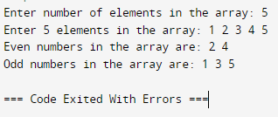

**9.Sum of Fibonacci series:**

**code:**

#include <stdio.h>

unsigned long long fibonacci_sum(int n) {

if (n <= 0) {

return 0;

}

long sum = 0;

long a = 0, b = 1, temp;

for (int i = 1; i <= n; i++) {

sum += b;

temp = a + b;

a = b;

b = temp;

}

return sum;

}

int main() {

int n = 10;

long sum = fibonacci_sum(n); printf("Sum of first %d Fibonacci numbers is: %lu\n", n, sum);

return 0;

}

**Output:** Sum of first 10 Fibonacci numbers is: 143

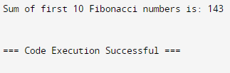

**10.Factorial of a number:**

**code:**

#include <stdio.h>

int main() {

int n, i;

long fact = 1;

printf("Enter an integer: ");

scanf("%d", &n);

if (n < 0)

printf("Error! Factorial of a negative number doesn't exist.");

else {

for (i = 1; i <= n; ++i) {

fact *= i;

}

printf("Factorial of %d = %lu", n, fact);

}

return 0;

}

**Output:** Enter an integer: 5

Factorial of 5 = 120

